DILSHAD
231501041

DATE: EXPERIMENT-2

AIM:
Write JavaScript to validate the following fields of the Registration page.
a) First Name (Name should contains alphabets and the length
Should not be less than 6 characters).
b) Password (Password should not be less than 6 characters length).
c) E-mail id (should not contain any invalid and must follow the standard pattern name@domain.com)
d) Mobile Number (Phone number should contain 10 digits only).
e) Last Name and Address (should not be Empty).

CODE:
<!DOCTYPE html>
<html lang="en">
<head>
<meta charset="UTF-8">
<meta name="viewport" content="width=device-width, initial-scale=1.0">
<title>Registration Form</title>
<style>
body {
font-family: 'Poppins', sans-serif;
background: linear-gradient(to right, #00c6ff, #0072ff);
text-align: center;
margin: 0;
padding: 20px;
}
.container {
background: white;
padding: 30px;
border-radius: 15px;
box-shadow: 0px 4px 15px rgba(0, 0, 0, 0.2);
max-width: 450px;
margin: auto;
animation: fadeIn 1s ease-in-out;
}
@keyframes fadeIn {
from { opacity: 0; transform: translateY(-20px); }
to { opacity: 1; transform: translateY(0); }
}
h2 {
color: #333;
margin-bottom: 20px;
}
input {
width: 100%;
padding: 12px;
margin: 8px 0;
border: 1px solid #ccc;
border-radius: 8px;
font-size: 16px;
}
button {
width: 100%;
background-color: #007BFF;
color: white;
padding: 12px;
border: none;
border-radius: 8px;
font-size: 18px;
cursor: pointer;
transition: background 0.3s;
}
button:hover {
background-color: #0056b3;
}
</style>
</head>
<body>
<div class="container">
<h2>Register Here</h2>
<form onsubmit="return validateForm()">
<input type="text" id="firstName" placeholder="First Name">
<input type="text" id="lastName" placeholder="Last Name">
<input type="password" id="password" placeholder="Password">
<input type="email" id="email" placeholder="Email">
<input type="text" id="mobile" placeholder="Mobile Number">
<input type="text" id="address" placeholder="Address">
<button type="submit">Register</button>
</form>
</div>

<script>
function validateForm() {
let firstName = document.getElementById("firstName").value;
let lastName = document.getElementById("lastName").value;
let password = document.getElementById("password").value;
let email = document.getElementById("email").value;
let mobile = document.getElementById("mobile").value;
let address = document.getElementById("address").value;

let emailPattern = /^[a-zA-Z0-9._%+-]+@[a-zA-Z0-9.-]+\.[a-zA-Z]{2,}$/;
let mobilePattern = /^[0-9]{10}$/;

if (firstName.length < 5 || !/^[a-zA-Z]+$/.test(firstName)) {
alert("First Name must contain only alphabets and be at least 5 characters long.");
return false;
}

if (password.length < 6) {
alert("Password must be at least 6 characters long.");
return false;
}

if (!emailPattern.test(email)) {
alert("Enter a valid email address in the format name@domain.com.");
return false;
}

if (!mobilePattern.test(mobile)) {
alert("Mobile number must contain exactly 10 digits.");
return false;
}

if (lastName.trim() === "" || address.trim() === "") {
alert("Last Name and Address cannot be empty.");
return false;
}

alert("Form submitted successfully!");
return true;
}
</script>
</body>
</html>

OUTPUT: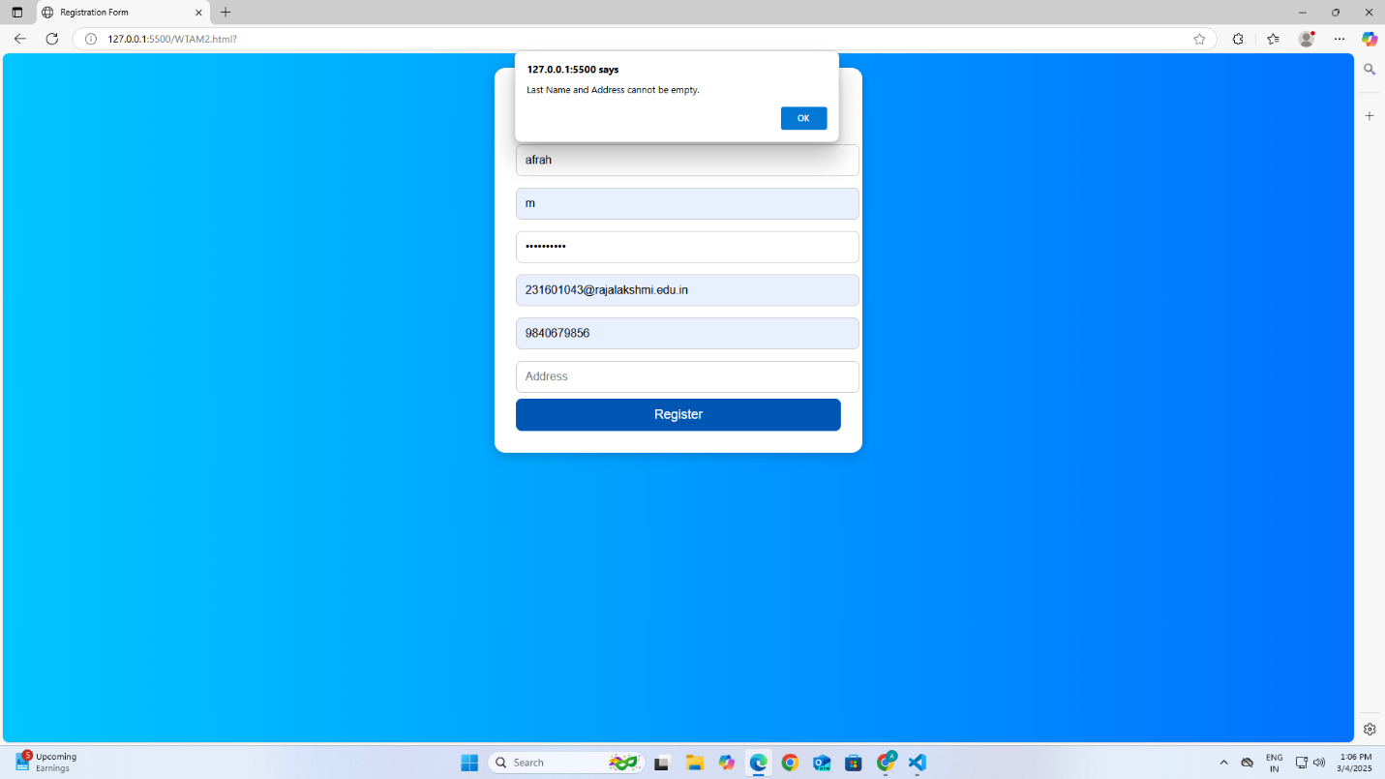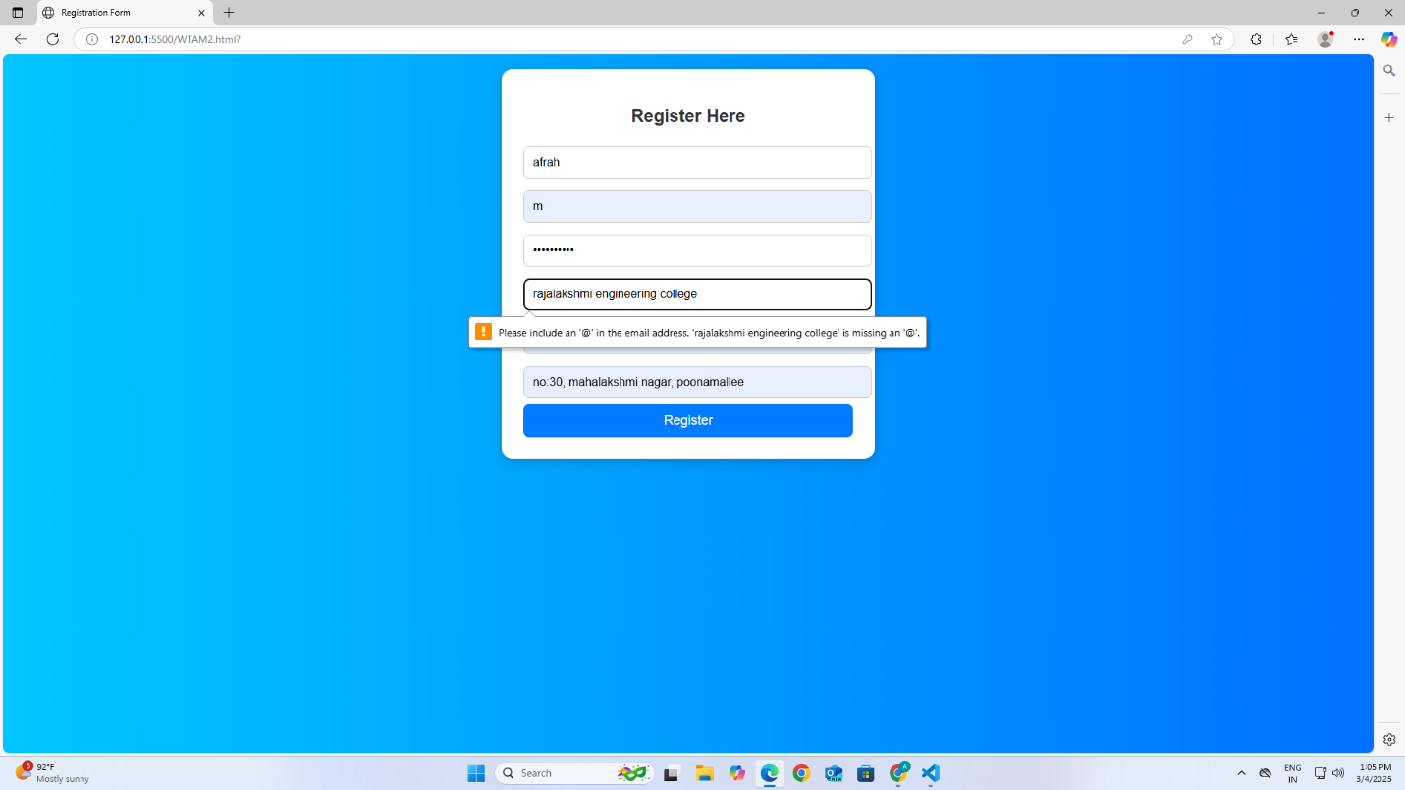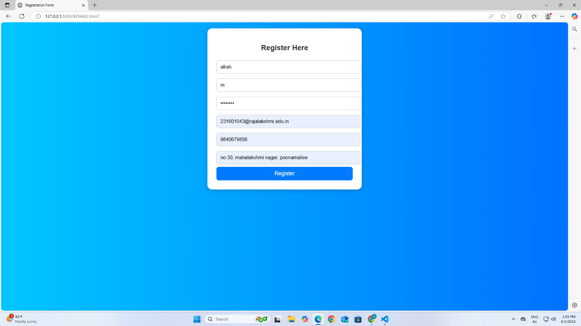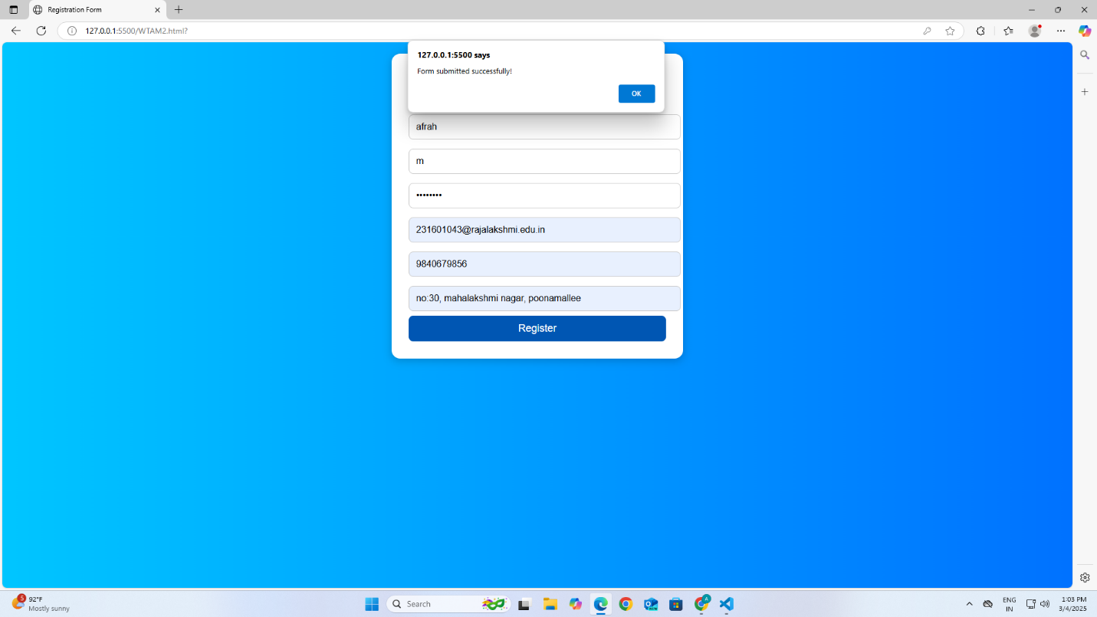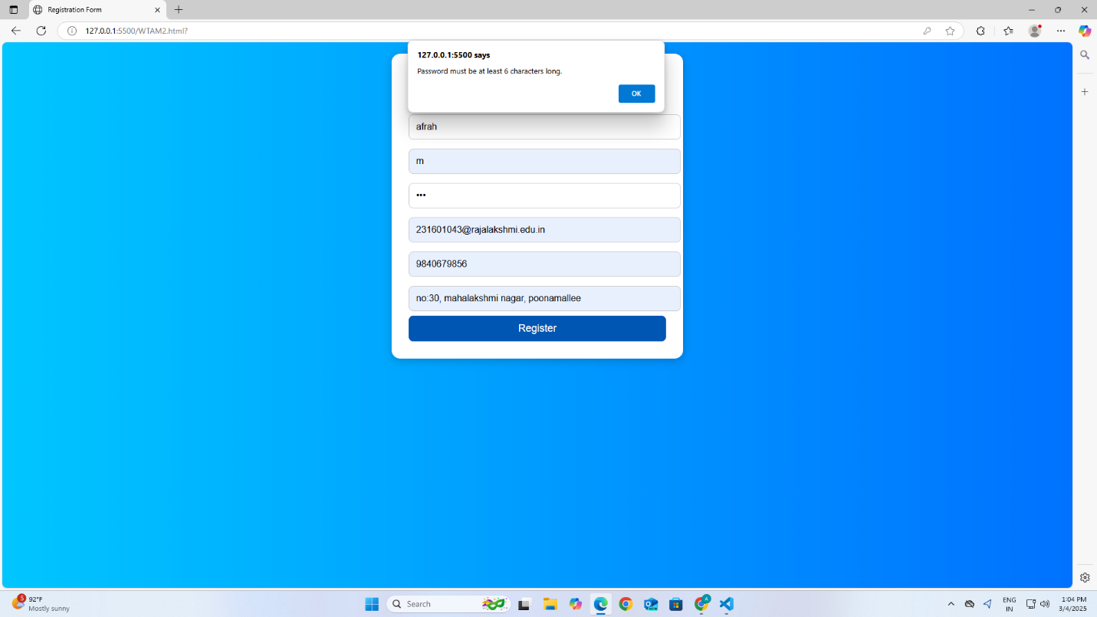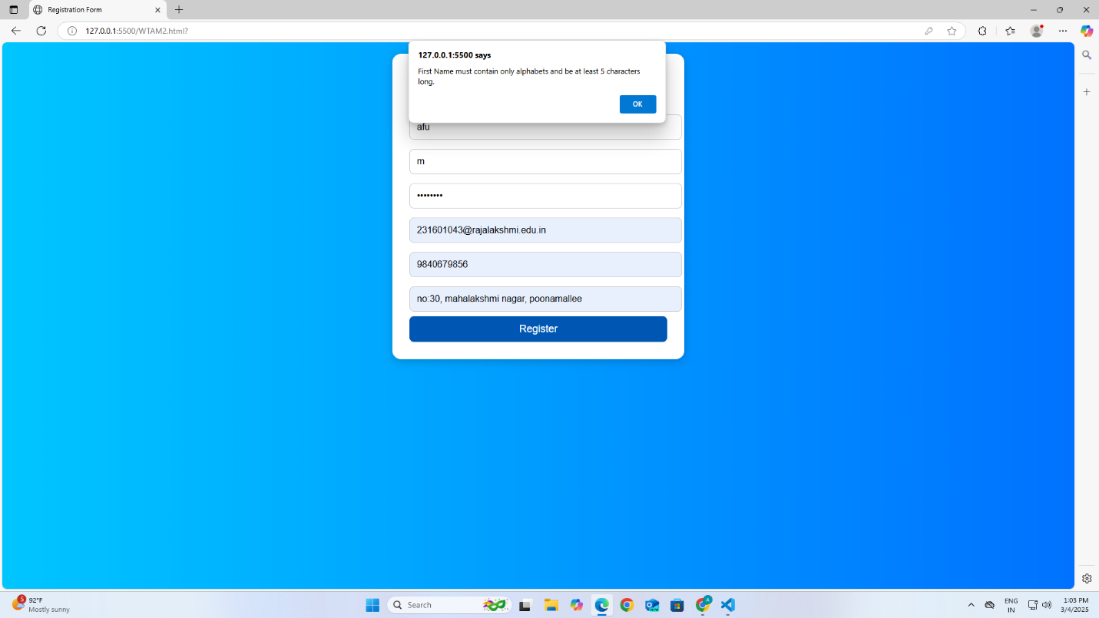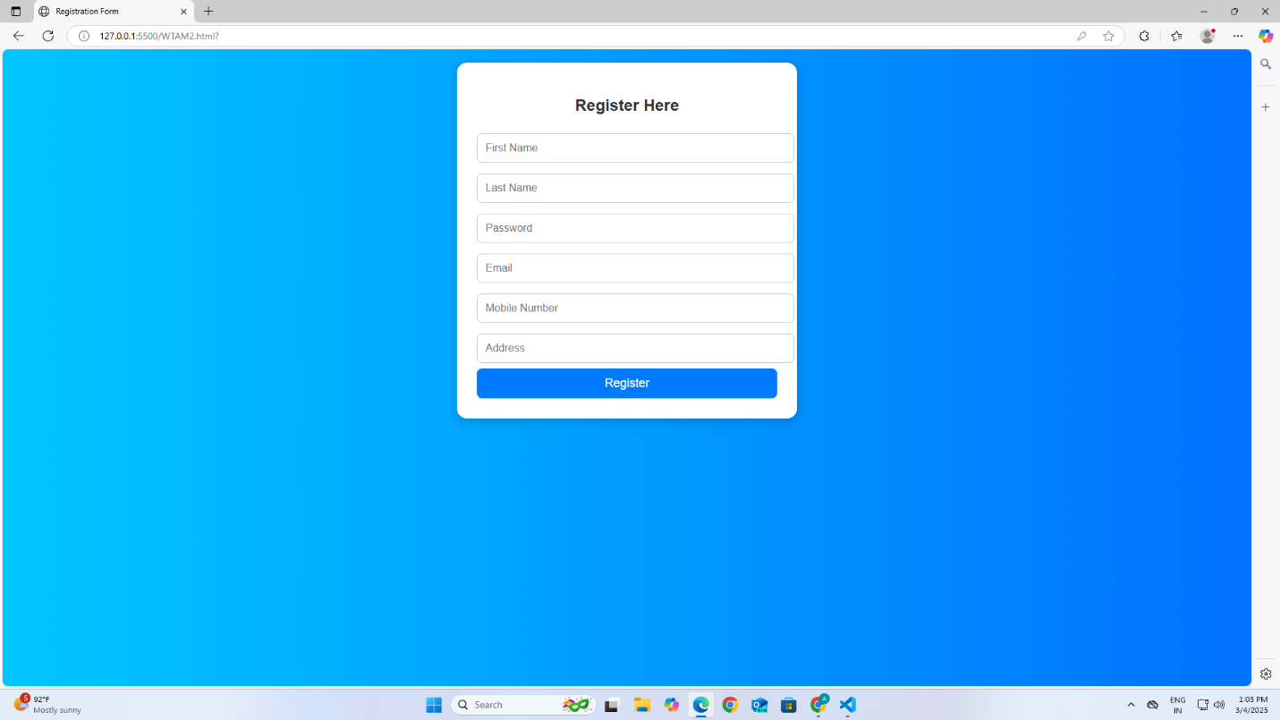

RESULT: Thus, a registration form was executed successfully.

